Template for FLAIR 2026 Book of Abstracts contributions

Erik Kerstel*¹, Silvia Viciani ², and Francesco D'Amato ²
¹ Université Grenoble Alpes / CNRS, LIPhy, 38400 Grenoble, France
² CNR – INO, via Madonna del Piano 10, 50019 Firenze, Italy
Email: flair2026@sciencesconf.org

Abstracts must be submitted in electronic format on the submission page of the conference website (http://flair2026.sciencesconf.org/), as this platform will be used to distribute the contributions to the reviewers. Please do not email your abstract to us, unless you encounter repeated problems during the regular submission process.
Abstracts may be provided in Microsoft Word (.doc or .docx) or PDF format. They should strictly adhere to this template and not exceed a length of one page A4. Accepted fonts are Times or Times New Roman. Title is 12 pt. bold face, Authors 11 pt., Affiliation and Email address 10 pt., while Body text is in 11 pt. References and figure or table legends are again in 10 pt. All margins are 2.5 cm. An asterisk (*) should identify the corresponding author. References are to be numbered and cited with the reference number(s) in square brackets. Please mention all authors with each reference, unless this would force the abstract to exceed the one-page limit; in this case mention only the first author followed by et al. As an example, we cite the editorial with the Special Issue of FLAIR2014 in Appl. Phys. B [1] and the obituary for Peter Werle [2].

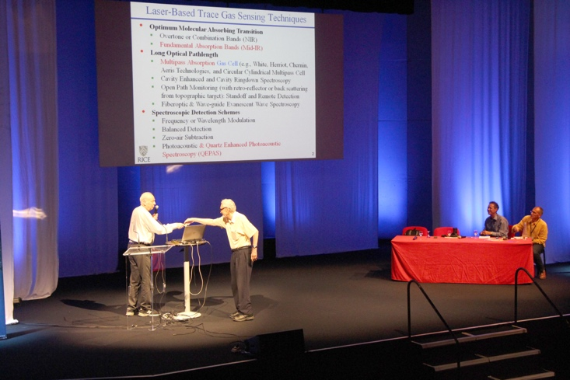
Figure 1: Frank K. Tittel and Robert F. Curl on stage during FLAIR 2016
Figures of 300-dpi resolution may be included. Color figures will be converted to grey scale in the printed Book of Abstracts. Therefore, please verify that all figures continue to be easily readable after conversion.
The web platform does not allow for text editing after submission, therefore please carefully proofread your abstract before submission. Abstracts that do not respect the above guidelines will be returned to the corresponding author.

References:
[1] F. D’Amato et al., Field laser applications in industry and research. Applied Physics B 119(1), 1-2 (2015).
[2] F. D’Amato, A. Fried, E. Kerstel, Obituary for Dr Peter Werle. Isot. Environ. Health Stud. 49(4), 575–578 (2013).

